**Assignment Cover Sheet**

To be completed **electronically** by the student and submitted with each piece of work. Please upload this completed cover sheet via Turnitin.

**Assignment Title:** Web Development (Web Development Project)

**Tutor: Mr. Danish Ali**

**Student Name: Jeevan Joseph**

**Student Number:** **2023-458**

**Date of Submission: 01/06/24**

For an online submission, please enter the URL of where your project files can be accessed (e.g., Google Drive). If a physical artefact, please provide further details on how this project has been submitted to tutors.

|  |
| --- |
| GitHub Repository Link: <https://github.com/jeevanjoseph1/jeevanjoseph1github.io.git>  Google Drive Link: <https://drive.google.com/drive/folders/17AiK1s2KSU6WUMTwiUg9VvfF9q_LXvm2?usp=sharing>  YouTube Video Link: <https://youtu.be/YrvZ86Odr-4> |

In submitting this assignment, I am confirming that I have read and understood the regulations for assessment, and I am aware of the seriousness with which the University regards unfair practice. Please see the universities [Unfair Practice Policy](https://thehub.bathspa.ac.uk/reference/student-policies/unfair-practice-policy) for details.

Signed: **Jeevan Joseph** Date: 01/06/23

**The Development Document**

* **Brief**:

I created a Real property corporation website for the organization “Primeproperty” with six pages creating the usage of HTML, CSS, AND JavaScript. The homepage shows an attractive design with photos and logos highlighting the numerous corporations to be had. The “About” page presents records about the corporation’s history and business. The “Service” page shows what the employer specializes in and what services it offers. The “Property” pages list homes currently listed for purchase and sale. The “Blog” web page gives brand-new blogs and news about the real estate market. Lastly, the “Contact” page consists of a touch form and organization place. Effective use of HTML, CSS and JavaScript enhances the design and functionality of the website.

* **Design Direction**:

I modified my inspiration from PropertyFinder, a website dedicated to selling residences. I analysed its functions, interface, and user enjoy for my internet site. For the Real property company website, I actually have chosen a current and minimalistic topic to create a expert and visually appealing internet site. The essential idea behind the layout is to create a sense of confidence, trust, and energy among potential customers.

Additionally, the sleek and simple design with uncluttered format affords smooth navigation and consumer-friendliness, making it without difficulty informative and inspiring for users to discover the net once more. The colours are carefully chosen to encourage professionalism and encourage confidence and assurance. These hues are synonymous with optimism, honesty and reliability in keeping with the employer’s cognizance on imparting wonderful offerings. Using emblems and pictures all around the website accomplishes matters.

First, Pictures offers customers a visible indication of the calibre of the enterprise’s services by way of casing already proven houses and closed transactions. Second, successful trademarks enhance the person enjoy via providing on the spot access to vital information. The important concept of the website is to put the corporation as a depended on and skilled company of actual property services, catering to the desires of both consumers and dealers. By combining easy layout, useful hues, and visually attractive factors, the internet site strives to go away a positive impression and instil self-belief in its site visitors. The primary aim is to encourage clients to touch the business enterprise for his or her actual property necessities, which include buying, selling, and making an investment, and to build relationships with them lasting as unswerving clients

* **Technical Description & Walkthrough**:

**Video:** [**https://youtu.be/YrvZ86Odr-4**](https://youtu.be/YrvZ86Odr-4)

* **Critical Reflection**:

Thinking greater cautiously about the development of “PrimeProperty”, many strengths and areas of improvement turn out to be apparent, firstly, the dynamic use of HTML, CSS and JavaScript builds a robust basis available for highlighting the website, and supplying a dynamic and visually attractive revel in. The inclusion of this era ensures that the internet site is expert and cutting-edge, that is vital to construct belief with potential customers in a competitive actual property industry.

Furthermore, HTML’s sematic structure complements accessibility and Seo, strengthening the internet site’s visibility and attain. However, one great location that needs to be improved is the functionality of the internet site. Ensure that ease of use throughout distinct gadgets and display screen sizes is important to maximize person engagement and pleasure. Using responsive design techniques and CSS media queries can correctly cope with this difficulty, imparting a constant user enjoy regardless of the device used.

Additionally, improving the internet site with interactive factors which includes hover effects or animations can notably raise consumer engagement and provoke visitors. To cope with these areas for growth, investment in competencies development is critical. Developing skills in the usage of CSS and media queries to put in force responsive layout strategies is crucial to growing an internet site that adapts seamlessly throughout gadgets. Additionally, studying JavaScript lets you combine interactive elements and animations, increasing the functionality and aesthetics of the internet site.

In conclusion, even as “Primeproperty” boasts strengths in its use of HTML, CSS, and JavaScript to create appealing and professional web sites, there are exceptional areas for development. Prioritizing responsiveness and interplay via reaction layout techniques, CSS media queries, and JavaScript can boom internet site functionality and user enjoy. By making an investment in abilities improvement and embracing these trends, “Primeproperty” can position itself as a main contender in a competitive actual property market, pleasing the needs of its target market and manipulate expectations efficaciously.

**Certifications**:

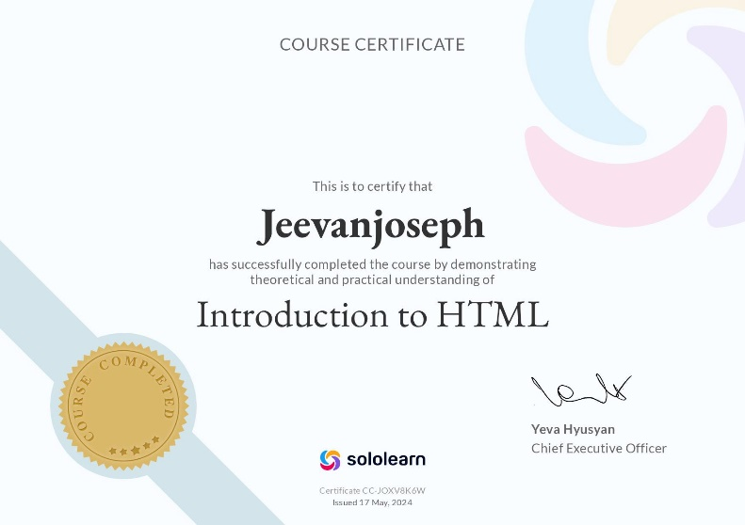

[**https://www.sololearn.com/certificates/CC-JOXV8K6W**](https://www.sololearn.com/certificates/CC-JOXV8K6W)

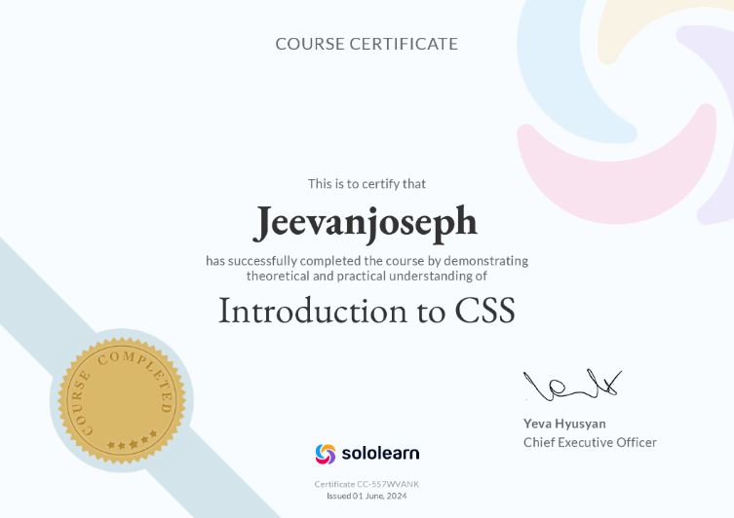

[**https://www.sololearn.com/certificates/CC-5S7WVANK**](https://www.sololearn.com/certificates/CC-5S7WVANK)

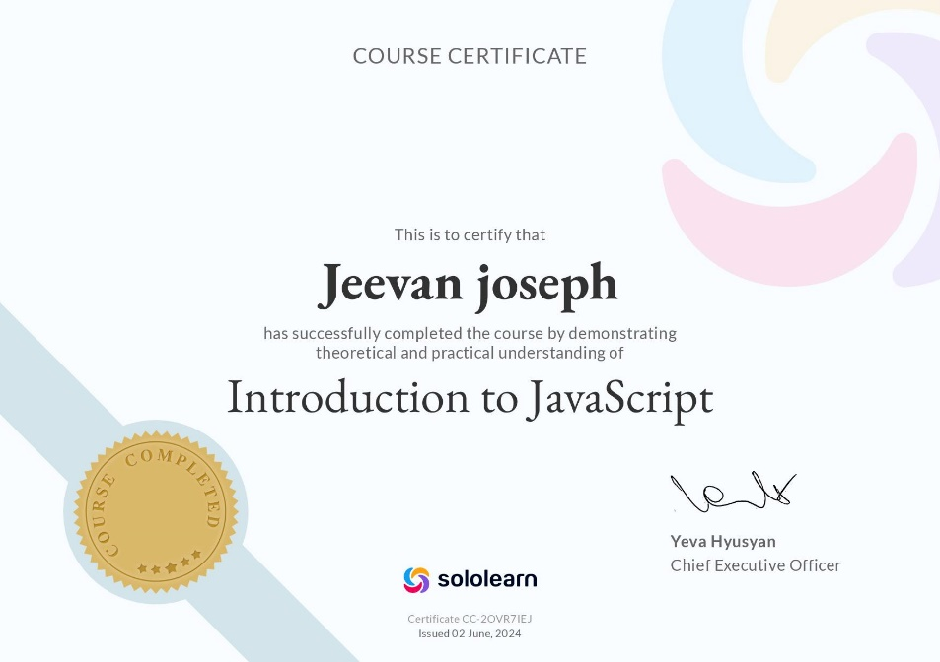

[**https://www.sololearn.com/certificates/CC-2OVR7IEJ**](https://www.sololearn.com/certificates/CC-2OVR7IEJ)